
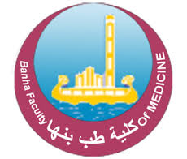

CURRICULUM VITAE

Of
Dr/ Shimaa Gamal Zaki Abdallah
Assistant lecture of internal medicine
Faculty of Medicine Benha University

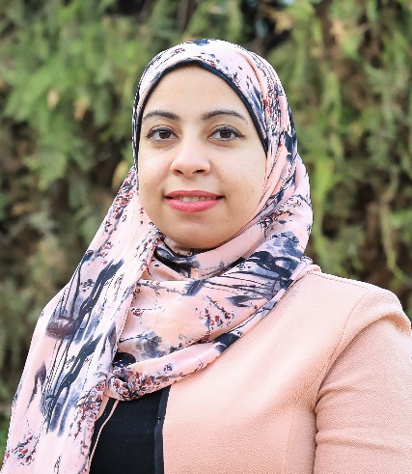
Personal photo
Personal Data:
Name (Arabic) | شيماء جمال ذكى عبدالله
Name (English) | Shimaa Gamal Zaki Abdallah
Department | Internal medicine
College | Faculty of Medicine
Academic degree | Assistant lecture
Mobile | 01094054320
Email (university) | shaimaa.abdallah@fmed.bu.edu.eg
Alternative E mail | shimaagamalzaki@gmail.com

Education:
Institution | Degrees obtained | Year
Benha Faculty of  Medicine, Benha university. | Master degree in internal medicine | 2020
Benha Faculty of Medicine, Benha  university. | Bachelor of Medicine and Surgery (M.B.B.Ch.) | 2014

Positions:
Organization | Position | year
Faculty of Medicine, Benha University | Demonstrator | 2019
Faculty of Medicine, Benha University | Assistant lecture | 2020  To date

publications:
- 8-iso-PGF2α as a marker of oxidative stress & its relation with glucose variability in type 1 diabetic patients (2018)

- Date of receipt of work:- 31/10/2019
- Appointment date:- 3/10/2019
- Date of birth :- 9/6/1990
- Marital status :- married

